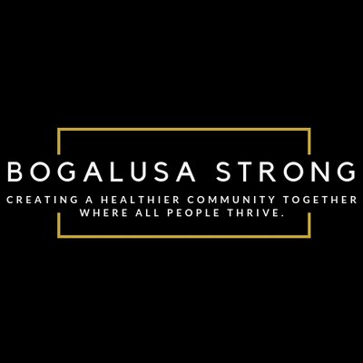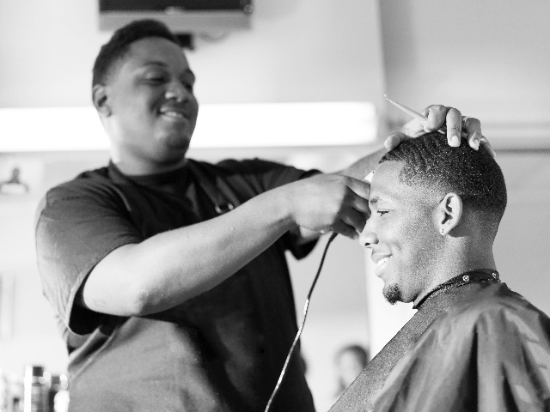­­­­­

Cutt’n the Pressure

City Name

High blood pressure usually shows no signs or symptoms. It is often called the silent killer.

A blood pressure screening takes less than 10 minutes. And, now it’s easier than ever.

During your next visit with your barber, ask him to check your blood pressure. He will refer you to a doctor if needed!

COMING SOON!

IN PARTNERSHIP WITH:

Barber’s Name

Barber Shop

*1234 Address Lane*

Barber’s Name

Barber Shop

*1234 Address Lane*

Barber’s Name

Barber Shop

*1234 Address Lane*

Barber’s Name

Barber Shop

*1234 Address Lane*