Sample Business Plan Template
Chronic Care Management Services

Mission Statement
Pharmacy Goal
What are you hoping to accomplish for your patients and your store by adding this service? (SMART goals – Specific, Measurable, Achievable, Realistic, Time-Limited)

Target Population
[PHARMACY] will provide Chronic Care Management services, both non-complex and complex, to eligible patients of [partner provider group]. These services will benefit individuals with multiple chronic conditions who are covered by Medicare. [Describe whether you are targeting a specific subpopulation, such as diagnosed with diabetes, high blood pressure, a certain age group, or those with high-risk medications]

Services and Products
The addition or expansion of Chronic Care Management services with an aim to improve chronic disease outcomes in the patient population.

Community Impact
How do you want the public to be aware of this service? [As you write this, consider whether there are other community organizations with whom you would like to increase collaboration. Well-Ahead partners with employers across the state as well as groups such as the YMCA and the LSUAgCenter. If you are interested in working more closely with another entity in your community to impact health, we may be able to help connect you.]

Business Impact
Highly innovative practice that [PHARMACY] can market to patients and prospective pharmacists. Offering this service increases our facility’s ability to attract and retain new pharmacists. CCM services are an ideal opportunity for partnership with primary care providers to increase our services and improve care for our patients, while also creating a new revenue source. It aids us in becoming a leader in the industry surpassing competitor services for pharmacy care. CCM services are a fee-based reimbursement, but have an impact on population health.

Description of the Business
[PHARMACY address]. The pharmacy hours are: [store hours]

[PHARMACY] employs [#] full time pharmacists [additional employees – pharmacy techs? Other staff?]

We fill on average [#] prescriptions daily, while also offering the following services: [description of current services]

Description of the Service
Chronic Care Management (CCM) is a set of non-face-to-face Medicare billable service that covers additional care management and access to care for eligible high-risk patients. With this collaboration with Well-Ahead Louisiana, we will be adding [clarify what new services will be added to existing chronic disease work]. We will enhance our partnership with [identify primary care providers] through Collaborative Drug Therapy Management agreements when possible.
- How does this enhance existing services?
- Will all pharmacists conduct CCM services?
- How will this service benefit patients?
- Key measures to define success:
  - # patients provided with services
  - # pts with controlled HTN
  - # pts with uncontrolled A1c levels
  - # pts with controlled cholesterol
  - # pts with improved medication adherence
  - Financial outcomes, new revenue generated
  - Patient satisfaction
  - Collaborating provider satisfaction
  - Patient cost-savings

Business Case
[detail findings of the SWOT analysis here]

Health needs of the community (demographics, disease burden, payer makeup)
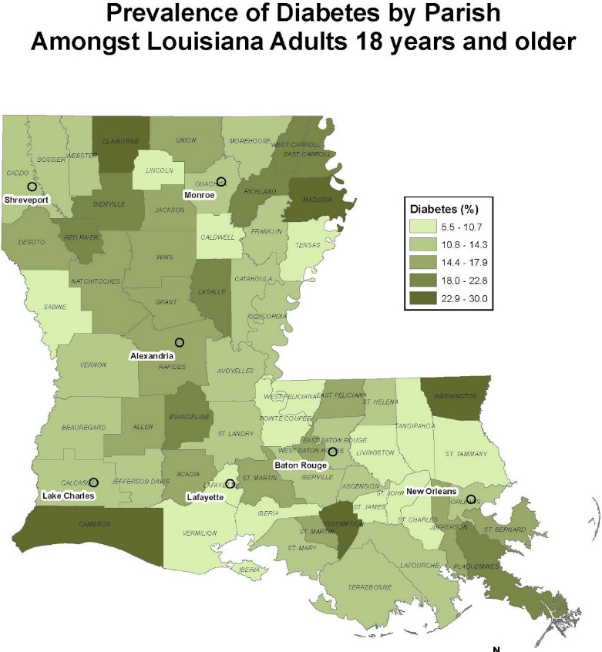
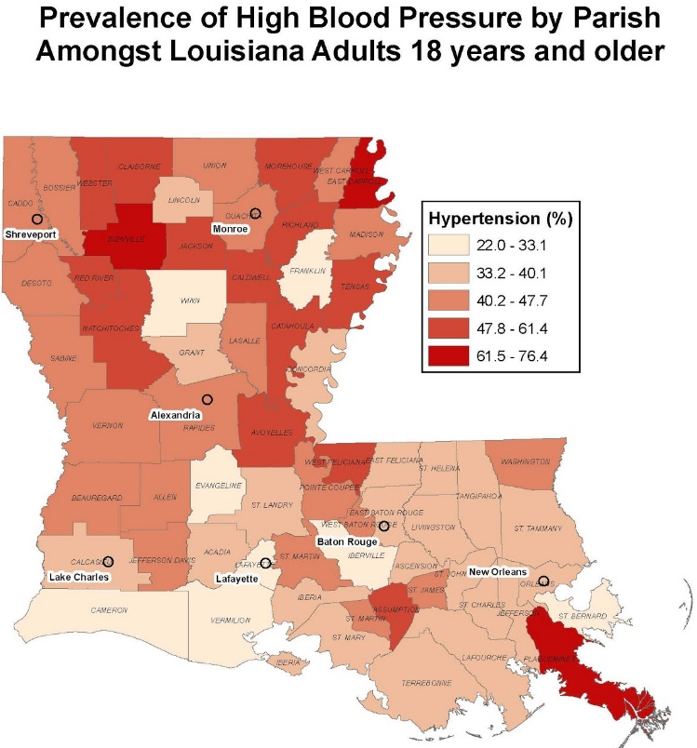

Are others in the area providing these services?
[Partners]
Project Management Team
Overview of participating pharmacists and their role.
(Include any relevant administrative or executive members from throughout the pharmacy/hospital that will be involved or critical to the success of the project. Note their specific role as it relates to this project. Include details on each team member’s qualifications specific to the success of this project.)

Financial Plan
Revenue expectations, income associated with new service (forecast 3 years if possible). This service cannot be billed directly by a pharmacist, and will require a Business Agreement with a partnering provider detailing how payment will be made for services provided.

When developing a business agreement, consider a Productivity-Based Revenue agreement. See Page 12 of the CPESN CCM Playbook for more detail.
- What population is being targeted?
- What are the reimbursement options available for this population?
  - Consider supporting a Business Agreement with a CDTM
  - Consider employer contract to provide these services to employees in partnership with a primary care provider
  - Patient self-pay

Costs associated with new service
- Start-up costs
  - Training (including travel if necessary)
  - New technology (if applicable)
  - New supplies (if applicable)
- Fixed costs
  - Salary
- Variable costs
  - Professional time for pharmacist

Expected volume
- Initial target – include expectations of pharmacist time to engage this volume, and plan for adjustment if more time needed than expected. Would more staff be hired if the service is more popular than expected? If more revenue is generated than expected? If more revenue could be brought in IF more staff is present?
- 3-year goals
  - Do you hope to expand over time?
  - Do you need specific data, software, accounting input to project your revenue to make the case for this service to your administration/owner?

Exit Strategy
If CCM is no longer financially feasible, how will pharmacy exit providing this service?
- Share this update with providers.
- Share this update with patients.
- Ensure that patients receive these services elsewhere.

Implementation Strategy
Evaluation Strategy
Quality Improvement
Describe what metrics you will use to determine how successful your program has been. This is an important step to demonstrate your effectiveness in the collaboration, and can help strengthen your case to attract new partners and additional business. Some keys to a successful QI strategy:
- Discuss what metrics are important to you and your partner provider as early in the process as possible.
- Determine what data you already have available in the EHR and your software
- For any data not available, think about how you will document this in a way that is consistent and able to be reported out
- Think about how you can visualize your outcomes in a way that makes it easy to see your impact.
- When possible, identify a national or statewide metric for comparison to your outcomes.

Suggestions of what to track
Patient outcomes: track chronic disease indicators over time and look for improvement in several key metrics: glucose, A1c, blood pressure, and cholesterol levels [others?]. Will patients be surveyed?

Cost savings: reduced costs both to the patient and the health system: out-of-pocket savings, decreased hospitalizations, decreased ED visits.

Process improvement: identify opportunities to improve collaboration: number of patients seen, time spent per month with each patient, successful billing, total revenue, generated, improved patient satisfaction. What measures, both outcomes and process, will tell us that this is working? How will we identify issues and address them quickly? Who is responsible for reviewing this information? How often will we review these measures? Will you have staff outcomes that you review, such as CEUs in this area, or regular training requirements?

