Sample Business Plan Template
Medication Therapy Management Services

Purpose
Work with your pharmacist and provider team to complete the sections of this Business Plan template on your own company’s letterhead or stationery. The document you create can be used in outreach to partner providers, to assist you in gaining leadership support, and serve as an overview as you assess and expand your program.

Mission Statement
Pharmacy Goal
What are you hoping to accomplish for your patients and your store by adding this service? (SMART goals – Specific, Measurable, Achievable, Realistic, Time-Limited)

Target Population
A broad overview of the target patient population, including eligibility criteria.

Services and Products
The addition or expansion of Medication Therapy Management services with an aim to improve chronic disease outcomes in the patient population.

Community Impact
How do you want the public to be aware of this service? (As you write this, consider whether there are other community organizations with whom you would like to increase collaboration. Well-Ahead partners with employers across the state as well as groups such as the YMCA and the LSU AgCenter. If you are interested in working more closely with another entity in your community to impact health, we may be able to help connect you).

Business Impact
Highly innovative practice that [PHARMACY] can market to patients and prospective pharmacists. Offering this service increases our facility’s ability to attract and retain new pharmacists. (Historically this increases prescription volume 5% in the store.) Medication Therapy Management services increases patient satisfaction, which can be demonstrated by patient surveys. Providing this service further increases pharmacists’ job satisfaction in the ability to utilize their knowledge to help patients manage their chronic diseases and provides diversity in job duties.

Expanding Medication Therapy Management services allows our facility to explore a potential new revenue source without taking a huge financial risk. It aids us in becoming a leader in the industry surpassing competitor services for pharmacy care.

Description of the Business
[PHARMACY address]

The pharmacy hours are: [store hours]
[PHARMACY] employs [#] full time pharmacists and [additional employees – pharmacy techs? Other staff?]

We fill on average [#] prescriptions daily, while also offering the following services: [description of current services]

Description of the Service
Medication Therapy Management are services provided by a pharmacist in a pharmacy, clinical, or other setting to ensure that a patient is receiving appropriate, effective and safe medication. With this collaboration with Well-Ahead Louisiana, we will be adding [clarify what new services will be added to existing chronic disease work]. We will enhance our partnership with [identify primary care providers] through Collaborative Drug Therapy Management agreements.
- How does this enhance existing services? [answer]
- Will all pharmacists conduct MTM services? [answer]
- How will this service benefit patients? [answer]
- Key measures to define success:
  - # patients provided with services
  - # patients with controlled HTN
  - # patients with uncontrolled A1c levels
  - # patients with improved medication adherence
  - # CDTM established with collaborating providers

Marketing Plan
[detail findings of the SWOT analysis here]

Health needs of the community (demographics, disease burden, payer makeup):
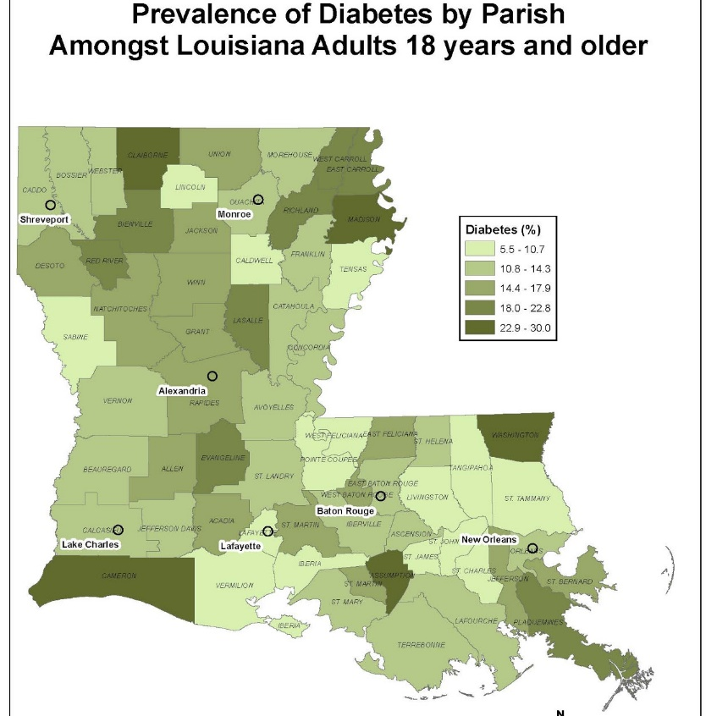

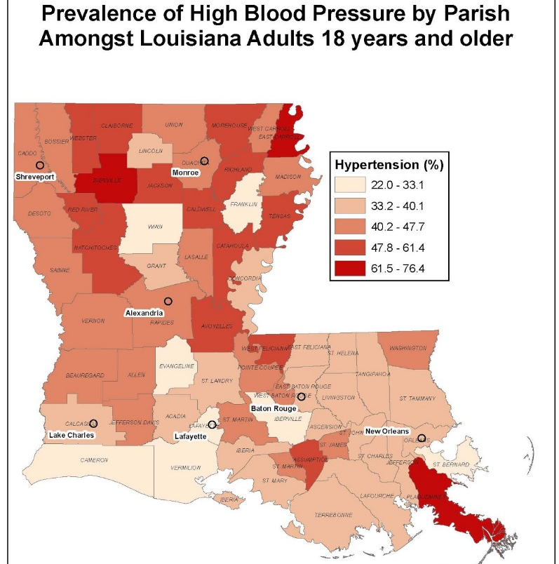

Are others in the area providing these services?
[Partners]

Project Management Team
Overview of participating pharmacists and their role.
(Include any relevant administrative or executive members from throughout the pharmacy/hospital that will be involved or critical to the success of the project. Note their specific role as it relates to this project. Include details on each team member’s qualifications specific to the success of this project).

Financial Plan
Revenue expectations, income associated with new service [3-year forecast if possible]
- What population is being targeted? [broad overview of the target patient population, including eligibility criteria]
- What are the reimbursement options available for this population?
  - Medicare Part D has billable CPT codes, but can only be done once per patient so must ensure that the patient has not received their annual CMR
  - Some Medicaid plans do reimburse for MTM for certain patients (Outline the feedback from the plans so far, noting that I have not spoken to the new plans)
  - Consider a contract with a provider, through a CDTM, to receive reimbursement for providing these services
  - Consider employer contract to provide these services to employees
  - Patient self-pay

Costs associated with new service
- Start-up costs
  - Training (including travel if necessary)
  - New technology (if applicable)
  - New supplies (if applicable)
- Fixed costs
  - Salary
- Variable costs
  - Professional time for pharmacist
- Other costs to consider:
  - Advanced Education: $1000
  - CDM credential: $250 to sit for exam and $50 annual fee + additional CE fees (if applicable)
  - PDA: $500
  - Lexi-comp software: $200 annually
  - Drug Identidex: $35 annually
  - [NATIONAL PHARMACY ASSOCIATION] membership: $295 annually
  - [STATE PHARMACY ASSOCIATION] membership: $295 annually
  - Pharmacist’s letter: $70 annually
  - Rx Consultant: $55 annually
  - AADE membership: $125 annually
  - Laptop: $1000
  - Pharmacist license: $108 annually
  - Preceptor license: $50 every 2 years
  - Documentation and billing software: [$X]
  - Loss of [X] hours per week pay from current employer [$X]/hr ~[$X] per month
  - High-speed internet service: $50 per month if not provided by current employer
  - Cost to start LLC - [WILL VARY ESTIMATE APPROX. $1000]
  - Cost of lawyer to look over/draw up contract with [PHARMACY]- [WILL VARY – ESTIMATE APPROX. $1500]

Expected volume
- Initial target (include expectations of pharmacist time to engage this volume, and plan for adjustment if more time needed than expected. Would more staff be hired if the service is more popular than expected? If more revenue is generated than expected? If more revenue could be brought in IF more staff is present?)
- 3-year goals
  - Do you hope to expand over time?
  - Do you need specific data, software, accounting input to project your revenue to make the case for this service to your administration/owner?

Exit Strategy
If MTM is no longer financially feasible, how will the pharmacy exit providing this service?
- Share this update with providers.
- Share this update with patients.
- Ensure that patients receive these services elsewhere.

Implementation Strategy

Utilize sample flow chart to outline the following:
- Pharmacist training
- Patient selection
  - Registry?
  - Pharmacy selection?
  - Referrals from Outcomes or other?
  - Referrals from other payer
  - Employer referrals
  - Patients of a specific collaborating provider
    - For this option, consider a CDTM.
- How will appointments be scheduled? Who is responsible for patient contact and follow-up?
- When will visit take place?
  - Face-to-face consultation
  - Phone consultation
- What will take place during patient visit?
  - Face-to-face
  - Phone
- Documentation process
  - What will you use for record keeping to meet MTM documentation requirements?
  - Billing process (will vary by payer)
  - How will you retrieve and track patient-specific data?
- Internal communication
  - How often will pharmacists meet, who is in charge of scheduling a meeting if needed?
- Communication with providers (especially if CDTM is in place)
  - How will this take place?
  - Who is in charge?
  - Do you need to meet with other MTM providers in the area?

Evaluation Strategy
Quality Improvement: How will this be evaluated and improved in an ongoing way?
- What measures, both outcomes and process, will tell us that this is working? How will we identify issues and address them quickly? Who is responsible for reviewing this information? How often will we review these measures?
  - Will patients be surveyed?
  - Will you compare your outcomes with national averages?
  - Will you have staff outcomes that you review, such as CEUs in this area, or regular training requirements?

